
Chutes and ladders
How to play and how to teach/practice with Chutes and Ladders?
- How to make the game?

Print the pictures, cut and laminate each part/number.

Take something big enough to serve as colored pawns. I use wrapped plastic bottles (half filled, to make them more stable). 

Take or make a die 

- What are the pictures on the cards?
Each picture represents an action. Here’s my key:

- How to play?
I divide the class into two groups.

Each group gets a pawn/bottle.
Give each student in a group a turn to throw the die. If, for example, the first die falls on #5, they put the pawn/bottle on square #5 on the board. Once they move their pawn, their turn is over. Keep in mind that two or more pawns may be on the same space at the same time.

The groups’ pawns will move back and forth across the board, following
the numbers upward. Sometimes they get to move up or down, depending on where their pawn “landed”.
Each time they stop you can ask a question about the material you are working on at that time. If their answer is faulty – they go back where they started from. You can decide whether to allow them to work as a team or only as individuals in the group (I usually like to let them work as a team, because they learn how to help and teach each other).
In addition to the questions, they have physical tasks they must do. That adds interest, competition and fun to the game. (you don’t have to stick to my tasks. You can invent your own.)

  1 |   2
3 | 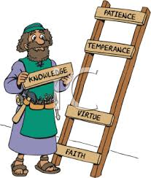  4
  5 | 6
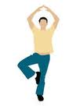  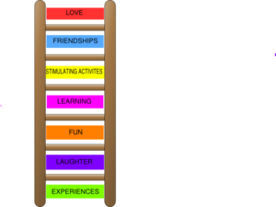  7 | 8
  9 | 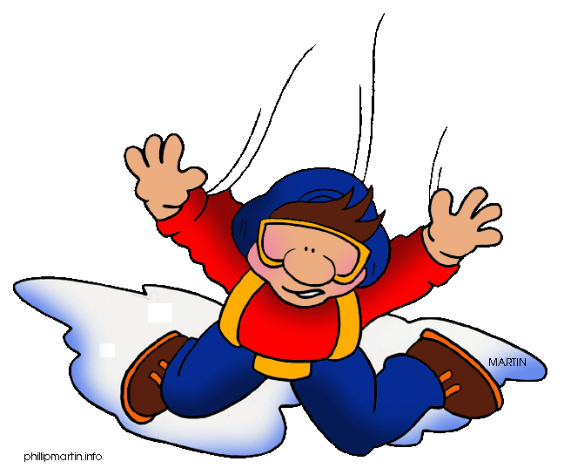  10
11 | 12
13 | 14
15 | 16
17 | 18
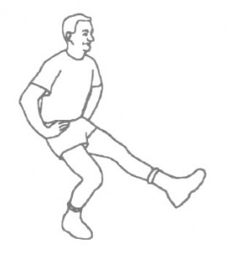    19 | 20
  21 | 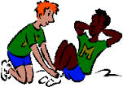  22
23 | 24
25 | 26
27 | 28
29 |   30

